**Detecting Particle Collisions**

**Objective:** In this lesson we’re going to make our lasers destroy the enemy ships and have the lasers bounced around a bit.

1. In your assets find the Laser prefab

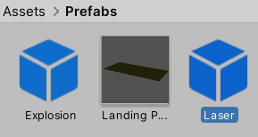

1. Find the Particle System module and look for Collision and turn it ON



1. Change the **Type** to **World.** This will allow the lasers to bounce and fly around.
2. Make sure **Send Collision Message** is turned ON. Now when the lasers collide with something that Collision will be accessible.



1. Go to Unity and test your changes. See how the lasers bounce around and create chaos. If you don’t want that to happen find **Min Kill Speed** and increase that to **1**.
2. Click on your **Sphere enemy** placeholder and make sure **Is Trigger** is turned **OFF**

**Optional:** if you want place a stationary 3D object on the path in front of you ship so you can reliably test the changes.

1. Go to the **Assets> Scripts** folder and create a C# script called **Enemy**
2. Attach this **Enemy** script to the **Sphere** or any GameObject that you set up for target practice.
3. Open **Enemy.cs** and delete the **Start** and **Update** methods.
4. We’re going to use the **OnParticleCollision** method

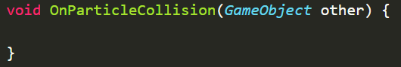

1. Inside of this method lets use Debug tools to log this collision



1. If you test the game out in Unity you should see this in your console

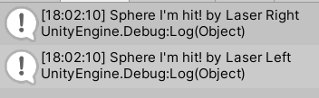

1. My concern here is that not ALL of my hits are registering. The lasers might be going too fast to detect a collision. Go to the Laser prefab and change **Start Speed** to **100**



If the lasers don’t look long enough increase the Trails > Lifetime field to 0.05

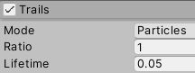

1. Go back to the script and use the Destroy function after the Debug

